**Training and Placement System - Project Management Documentation**

**1. Project Charter**

**Project Overview**

**Project Name:** Training and Placement Management System  
**Duration:** 12 months  
**Budget:** [To be determined based on scope]

**Project Purpose**

To develop and implement a centralized training and placement system that streamlines the placement process for educational institutions.

**Objectives**

1. Develop a fully functional placement management system
2. Implement within 12 months
3. Achieve 95% user adoption rate
4. Reduce administrative workload by 50%
5. Increase placement efficiency by 40%

**Stakeholders**

* Project Sponsor: Institution Management
* Project Manager
* Development Team
* Students
* TnP Coordinators
* Recruiters
* IT Department

**2. Work Breakdown Structure (WBS)**

**Phase 1: Initiation (Month 1)**

1. **Project Planning**
   * Requirements gathering
   * Stakeholder analysis
   * Resource planning
   * Risk assessment
2. **Technical Planning**
   * Architecture design
   * Technology stack selection
   * Infrastructure planning
   * Security framework

**Phase 2: Development (Months 2-8)**

1. **User Interface Layer**
   * Student Dashboard
   * Coordinator Dashboard
   * Recruiter Dashboard
   * Admin Panel
   * **Timeline:** 3 months
   * **Resources:** Frontend Team
2. **Application Logic Layer**
   * Notification System
   * Placement Management Module
   * Recruitment Tracking System
   * Calendar Management System
   * **Timeline:** 4 months
   * **Resources:** Backend Team
3. **Data Management Layer**
   * Database Development
   * Security Implementations
   * Backup and Recovery
   * **Timeline:** 3 months
   * **Resources:** Database Team

**Phase 3: Testing & Deployment (Months 9-11)**

1. **Testing Strategy**
   * Unit Testing
   * Integration Testing
   * User Acceptance Testing (UAT)
   * Performance Testing
   * Security Testing
   * **Timeline:** 2 months
2. **Deployment Strategy**
   * DevOps Pipeline Setup
   * Server Configuration
   * CI/CD Implementation
   * Production Rollout
   * **Timeline:** 1 month

**Phase 4: Maintenance & Optimization (Month 12+)**

1. **Bug Fixes & Enhancements**
   * Continuous updates
   * User feedback integration
2. **Support & Documentation**
   * Training guides
   * User manuals
   * Technical documentation

**3. Project Timeline**

|  |  |  |
| --- | --- | --- |
| **Phase** | **Task** | **Duration** |
| Initiation | Planning & Risk Assessment | 1 Month |
| Development | UI, Backend, Database | 6 Months |
| Testing & Deployment | Testing & CI/CD Setup | 2 Months |
| Maintenance | Support & Enhancements | Ongoing |

**4. Risk Management**

**Technical Risks**

* Data Security & Privacy Concerns
* System Scalability Issues
* Integration Challenges

**Business Risks**

* Low User Adoption
* Budget Overruns
* Regulatory Compliance Issues

**Mitigation Strategies**

1. Implement security best practices (Encryption, Access Controls)
2. Regular Performance Testing & Scaling Plan
3. Conduct User Training Programs

**5. Features of the Training and Placement System**

1. **Student Module**
   * Profile Management
   * Resume Builder
   * Job Application Tracking
   * Training and Internship Registration
   * Notification and Alerts
2. **TnP Coordinator Module**
   * Student Profile Verification
   * Job Posting and Approval
   * Placement Report Generation
   * Event Scheduling
   * Communication Hub
3. **Recruiter Module**
   * Company Profile Management
   * Job Posting and Criteria Setup
   * Resume Shortlisting and Selection
   * Interview Scheduling
   * Feedback Submission
4. **Admin Module**
   * User Management
   * System Configuration
   * Role-Based Access Control
   * Security and Compliance Monitoring
   * Data Analytics and Reports
5. **General System Features**
   * AI-Driven Job Recommendations
   * Automated Notification System
   * Cloud-Based Storage
   * Multi-Platform Accessibility
   * Data Security and Privacy Compliance

**6. Architecture Diagram**

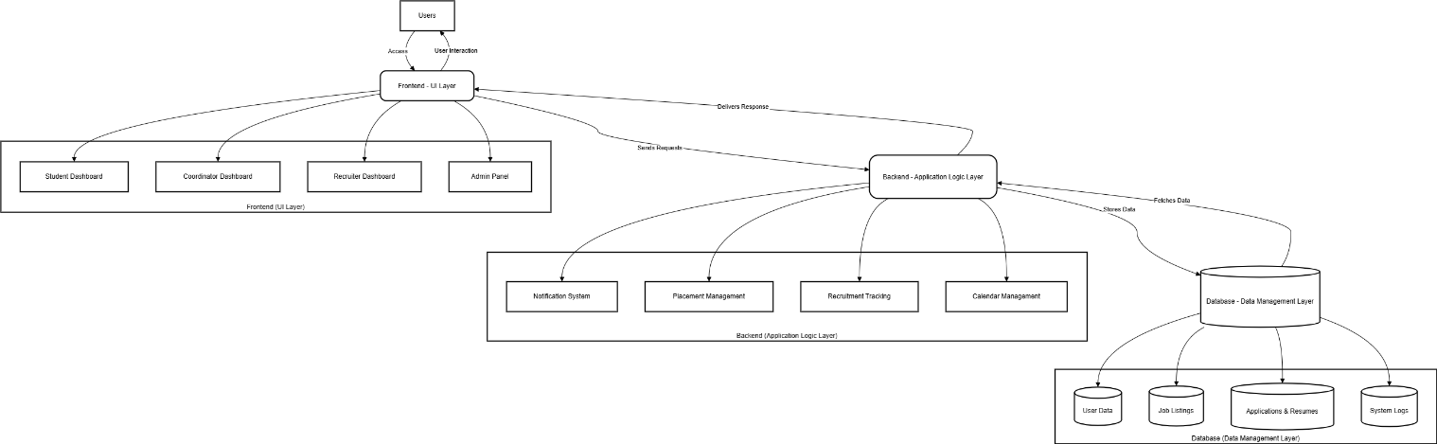

**7. System Flow Diagram**

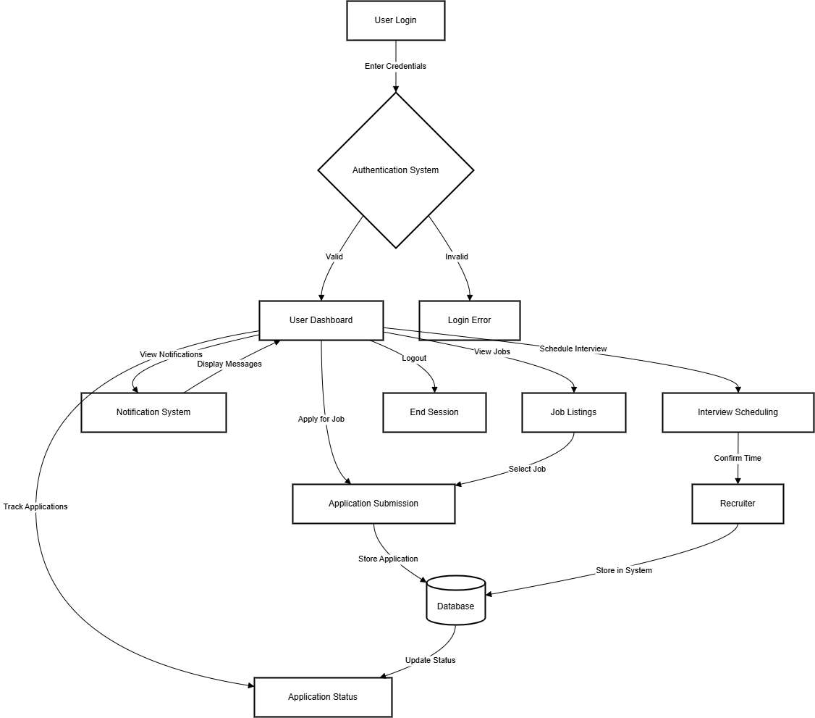

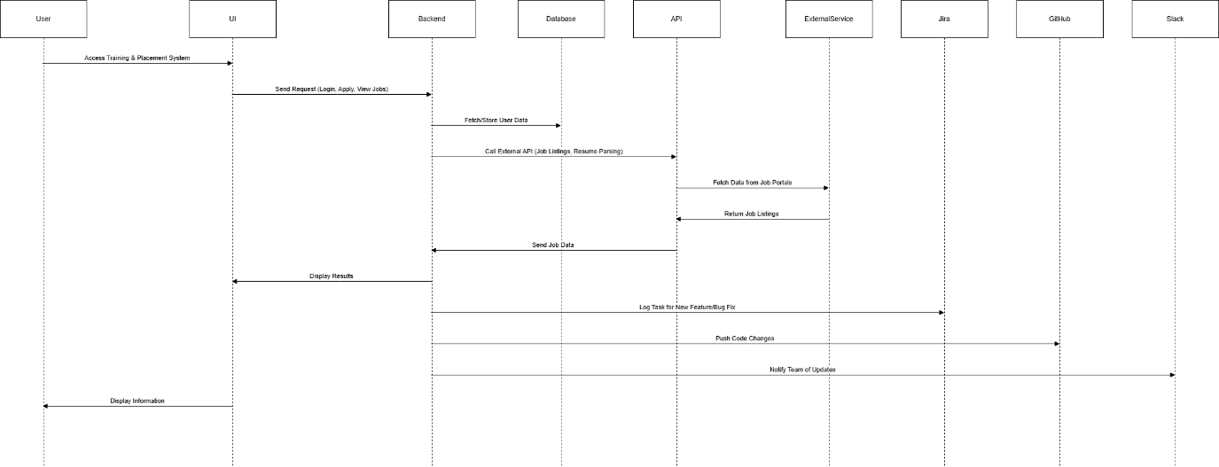

**8. Conclusion**

The Training and Placement System aims to provide a seamless experience for students, recruiters, and coordinators by integrating efficient workflows, AI-driven insights, and automation to streamline the placement process. With a structured project management approach, this system ensures on-time delivery, scalability, and long-term sustainability.